Art Project Ideas for at Home Teacher Mr. Mueller
Note we have one term of Art left in this semester. Choose Four Projects from the above Criteria, to complete this course and remember, If you need some supplies please do not, hesitate to contact Mr. Mueller for a package.
Art 9-10

Hello everyone! We are living in a very interesting time of history, our routines, hobbies, interests, and friend ship dynamics have changed for the time being, we are in a temporary “pause” in our lives. From an educational approach this is going to be a whole new slant on teaching and learning that we are about to experience.
If we stop to think about how this is going to apply to art I think we will all find that this is an awesome opportunity to think out of the box and to be creative. We will have time to focus with limited distractions. What better opportunity do we have to be creative and make art?
Some of us have supplies in which to use at home and some of us do not, but don’t let that stop you, all you really need is a pencil or pen. Maybe you have, a pocket Knife, and a block of firewood that you can carve with, perhaps you have your little brother or sisters finger paints, or scraps of fabric or glue. Maybe even your dad or mom will allow you to use some of their tools? There are many artistic mediums that you can use or find that are inexpensive. Take a walk into the forest and find those unique items that you can build a project with. Some of the worlds greatest art has been made from what ever can be found around you. How creative can you be? Take a risk, be inspired and look at all the amazing things that can be created because of this experience.
Below I will provide web sites and imagery ideas for projects that will give you some ideas in which to help you create a project. You can reference these, or you can create and build your own projects using ideas that you have formulated. Please if you have any questions do not hesitate in contacting me for assistance. Thank you guys I hope this resource helps you be your creative self. I miss coming to work everyday and seeing your enthusiasm. This time will pass, but in the meantime lets be as creative as possible and have fun with this opportunity to make art!
I am super excited about the potential of these projects. When they are all completed I would like to create a virtual web site that we can display all of our at home creations on. We could make it really fun with some selfie critiques, talking about what we learned, we could interact, and bounce ideas off of each other while we are in this creative process.
I have provided blow some ideas for projects that you can explore, remember these are just Ideas if you have other art interests, you would like to pursue flow the creative process of inquiry-based learning below. This is an awesome opportunity to use this concept of learning.
Choose 3 projects from below or from the curriculums or send me a proposal of a project you would like to pursue. You will notice on the website, that all the Art curriculums from grades 8-12 will also be available to utilize.
If you need, certain supplies I can build a package for you. Send me an email and I will do my best to help there. Certain supplies may not be available, but that will come up in our email contact.

What is Inquiry Based learning?

Take this time to develop the concept of “Inquiry based learning” Use the creative process of: Ask, Investigate, Create, Discuss, and Reflect, to gain a fullness of your creative experience.
Inquiry-Based Learning (IBL) is an approach to teaching and learning in which the classroom environment is characterized by the student being the active participant while the teacher’s role is decentralized.

Our present situation with Covid-19 and social isolation practice is the perfect setting in which to build this learning skill set. Inquire, compose, and create, use me a for a reference, or guide. Stay in contact, ask questions, and bounce ideas off me. Ask advice, and talk layout strategy, together through art, lets turn this time away from the school setting into a positive time to create some amazing art work!
I look forward to interacting with all of you in the coming months, Lets do this have fun and see what we can create. Feel free to contact me via email at vmueller@sd91.bc.ca or through my Art blog

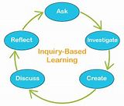

Found Object Art
This is a fun project, art can be really simple, everyday objects can be made into all kinds of very interesting art work. Take a quick look around for discarded objects and start arranging them and see what starts to come together. I always take a close look at each individual piece and look for specific character references and build the subject around the dominant piece. Have fun I think you will be surprised at what you come up with. If you have crazy glue, epoxy, or a hot glue gun it will come in handy when attaching the various objects. I can’t wait to see what you create?
https://www.bing.com/images/search?q=found+art+ideas&qpvt=found+art+ideas&FORM=IGRE

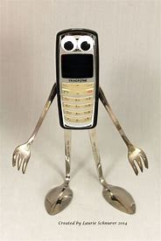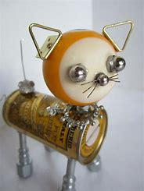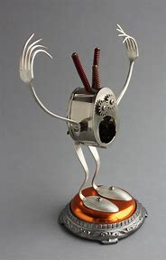

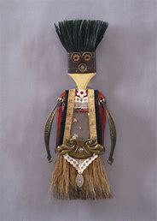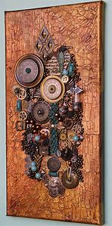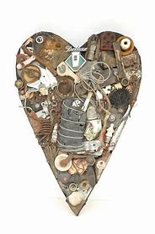

Making Art Using Words
Hi guys this is a real fun project that ties drawing in with words. You will have fun with this one, I personally have done several drawings when I was in university using script. Tie the words in with your theme and create a really cool drawing. You can combine imagery and script to build a message. Hmmm what could you create using words around Covid-19? What imagery would you incorporate into the drawing to make it applicable?
https://www.bing.com/images/search?q=drawing+imagery+over+words&FORM=HDRSC2
Mediums: Pencil Crayons, water colors, markers, charcoal, pastel, and graphite are just some of the mediums you can use.
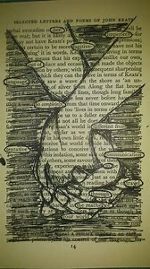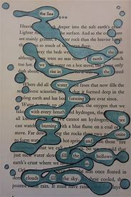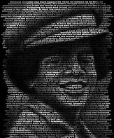

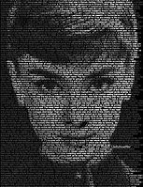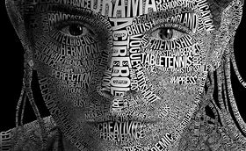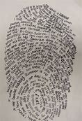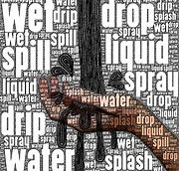
Making Art from Nature
This project can be a lot of fun, and it gives you a good excuse to get out of the house and go for a social distancing walk. As your walking through the nature trail, or the back field or near by forest, look for those unique things created by nature, odd twists in a branch, old mans beard, different types of fingus, and or dried grass can give you the necessary pieces to help you begin your art work. It can be big or small, and all you may need to put it together is a screw gun, maybe a little hot glue, or a stapler. Add a little sand maybe some rocks and then you have some texture. Again, you can have a lot of fun with this project.
https://www.bing.com/images/search?q=making+art+from+nature&qpvt=making+art+from+nature&FORM=IGRE

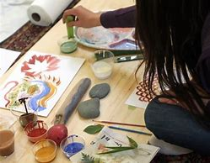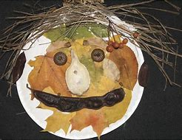
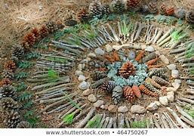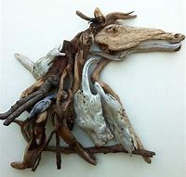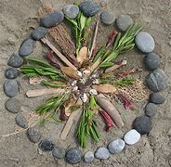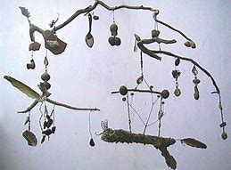

Social Isolation Window Drawing

I call this the social isolation window drawing, this is a unique view that is directly related to what we all may be experiencing at this time. In this assignment, you will first draw your actual window shape and frame. From there pending on the view you have through your window you will draw either a landscape or city scape that you see out of the window. Don’t be afraid to add and subtract imagery to portray this specific time. Remember to use the four basic steps to successful drawing, be detailed and creative, and don’t be afraid to experiment with a variety of mediums and drawing techniques that you have learned.

https://www.bing.com/images/search?q=drawing+from+your+window&FORM=HDRSC2

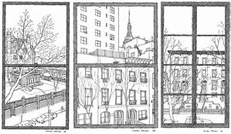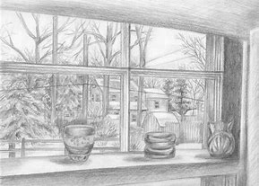
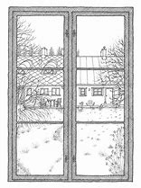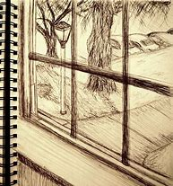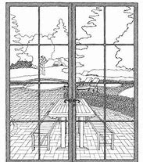

The Concept of Foreshortening
to reduce or distort (parts of a represented object that are not parallel to the picture plane) in order to convey the illusion of three-dimensional space as perceived by the human eye: often done according to the rules of perspective. to abridge, reduce, or contract; make shorter.
For this project you will experiment with the concept fore shortening, depth of field, and distortion, while drawing the human form. As we know from other assignments we have completed earlier in the year that size relationships change when placed in a depth of field. The human body is no different. In this assignment you will experiment drawing the human body in a variety of different poses. Use your phone to take selfies. Make sure you are super creative, dress up come up with a theme. Think about the 3 perspectives as, what can you do to draw more interest to your subject?

Don’t be afraid to experiment with a variety of mediums. Have fun with this project.

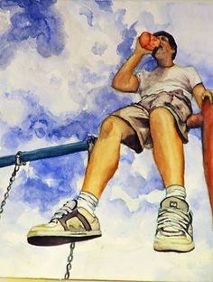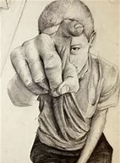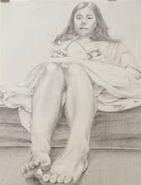

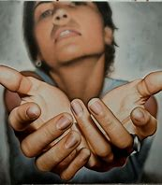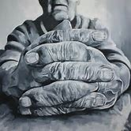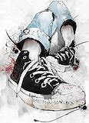

Drawing Everyday Objects Using and Non-Traditional View Points.

In this project you are going to draw a random object from a perspective that you normally would not view it. By changing the perspective, you generate a whole new feel for the subject. Simple everyday objects can take on a whole new interest when they are viewed from a different perspective. If it’s a small object make it huge, pay special attention to the little details. Consider a variety of different drawing techniques, try different mediums, pens pencil crayons, pens, markers, paint, or whatever you have available. Use different drawing techniques, gestural drawing, contour, or 1, 2, or 3-point perspectives. Have fun with this project.

th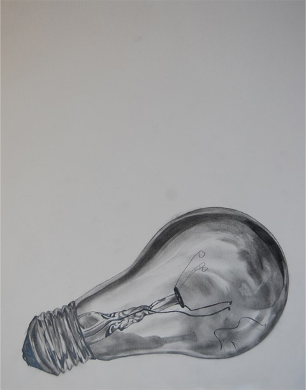e human f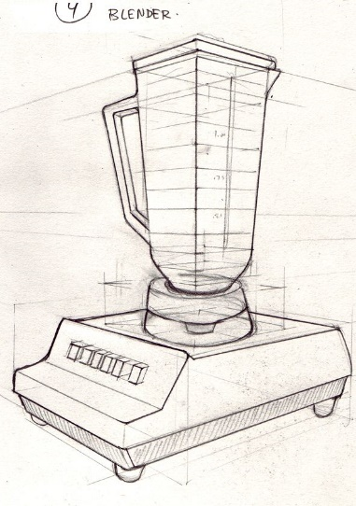o 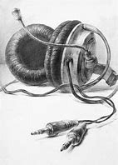
ng